Chapter 3
Requirement Analysis

3.1 Introduction to Requirement Analysis
This chapter presents a structured and formal specification of system requirements for AgriGrow. The purpose of this chapter is to clearly define what the system shall accomplish before proceeding to the system design phase. The requirements documented in this chapter serve as a contractual foundation for implementation, validation, and system testing. The requirement analysis includes requirement elicitation techniques, identification of stakeholders, use case modeling, functional requirements, non-functional requirements, and external interface requirements. All requirements are written in measurable and testable format using standard requirement engineering principles. AgriGrow is specifically tailored to address the needs of local farmers by providing offline-capable AI diagnostics for regional crops like wheat, rice, and sugarcane, ensuring robust accessibility in low-connectivity rural areas.

3.2 Requirement Elicitation Techniques
This section describes the techniques used to gather and refine system requirements. Requirement elicitation ensures alignment between stakeholder expectations and system capabilities. Requirements for AgriGrow were identified using the following techniques:
- Stakeholder interviews to capture user expectations regarding language barriers and offline operational constraints.
- Literature review of local agricultural challenges and crop disease patterns (e.g., wheat rust, rice blight).
- Analysis of existing solutions (like Plantix) to identify critical functional gaps, primarily the heavy reliance on continuous internet access.
- Dataset examination and feasibility study to ensure MobileNetV2 can accurately detect localized crop diseases on mobile devices.

3.3 User Classes and Characteristics
This section identifies different user categories interacting with the system. This classification supports role-based access control and requirement mapping. Table 3.1: User Classes and Characteristics
User Class | Description |  | Technical Level
Administrator |  | Manages system configuration, updates the LLM knowledge base, monitors community forum activity, and manages user accounts. | Advanced
End User (Farmer) |  | Uses the system to perform | Basic
User Class | Description | Technical Level
 | core functionalities such as offline crop disease diagnosis, yield estimation, and accessing localized advisory services.
External System | APIs (Google Maps) interacting  with the application for geospatial area calculations. | Technical

3.4 System Overview
The proposed AgriGrow system operates within a structured Progressive Web App (PWA) architectural environment designed to support modular interaction between user interfaces, local processing logic, and cloud data synchronization. The system supports role-based interactions, enabling farmers to access core diagnostic features completely offline, while allowing administrators to manage community data online. By embedding machine learning models directly into the browser via TensorFlow.js, the system boundary encompasses local device storage, camera hardware, and edge processing capabilities. It ensures secure communication between internal modules and external services, such as the Google Maps API, when network connectivity is restored, ultimately creating a seamless and resilient digital farming assistant.

3.5 Use Case Model
The use case model represents high-level system interactions between actors and system functionalities. It defines system boundaries and captures functional behavior from a user perspective.

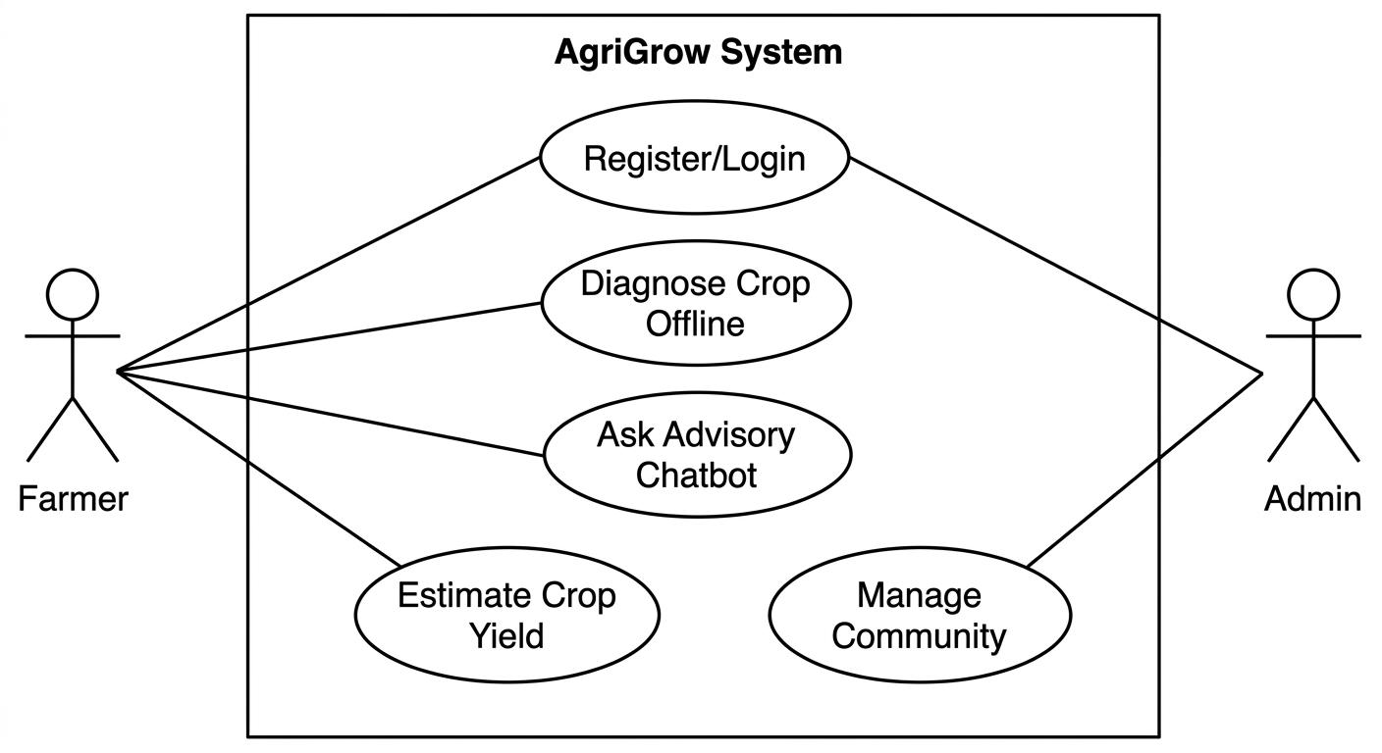
3.5.1 Use Case Diagram

3.5.2 Use Case Descriptions
This section provides detailed tabular specifications of major use cases.

3.5.2.1 Module 2: Core System Functionality Table 3.2: UC-2.1: Offline Crop Diagnosis
Field | Description
Use Case ID | UC-2.1
Use Case Name | Offline Crop Diagnosis
Actors | End User (Farmer)
Description | This use case describes how a user diagnoses
Field | Description
 | a crop leaf (wheat, rice, sugarcane) offline.
Trigger | User selects the "AI Crop Doctor" option.
Preconditions | The PWA and TensorFlow.js model are cached on the user's mobile device.
Postconditions | Disease diagnosis and localized treatments are successfully displayed.
Normal Flow | 1. User selects target crop type. 2. User captures a photo of the leaf. 3. System processes the image locally. 4. Diagnostic results and treatments are displayed in the regional language.
Alternative Flow | If the image is unclear, the system displays an error and prompts for a retake.

3.5.3 Event-Response Table
The event-response table defines how the system reacts to significant internal and external events.

Table 3.3: Event-Response Table
Event | Source | System Response
User Login Attempt | End User | Validate credentials locally or via server and grant/deny access.
Language Toggle | End User | Dynamically translate the UI into Urdu, Punjabi, Pashto, or Saraiki.
Crop Image Capture | End User | Execute local AI model (MobileNetV2) and display prediction results.
Area Calculation Request | End User | Fetch Google Maps API data, calculate acreage, and estimate yield.

3.6 Functional Requirements
Functional requirements define the core services and behaviors that the system shall provide. Each requirement is uniquely identified, measurable, and written using formal specification language.

3.6.1 Module 1: User Management & Localization

3.6.1.1 FR-1.1 User Registration Table 3.4: Functional Requirement – User Registration
Identifier | FR-1.1
Title | User Registration and Authentication
Requirement | The system shall allow users to create an account and authenticate using a valid email or mobile number.
Identifier | FR-1.1
Source | Stakeholder Requirement
Rationale | Enables authorized access to system services and community features.
Dependencies | Database Connectivity
Priority | High

3.6.2 Module 2: AI Crop Doctor (Core Processing)

3.6.2.1 FR-2.1 Offline Inference Processing Table 3.5: Functional Requirement – Core Processing
Identifier | FR-2.1
Title | Execute Offline Crop Diagnosis
Requirement | The system shall process uploaded crop images locally without an internet connection to predict diseases with a confidence score.
Source | System Requirement Specification
Rationale | Enables delivery of the primary system value proposition in low-network areas.
Dependencies | TensorFlow.js Model Cache
Priority | High

3.6.3 Module 4: Area Calculator & Yield Estimator

3.6.3.1 FR-4.1 Geospatial Yield Estimation Table 3.6: Functional Requirement – Yield Estimation
Identifier | FR-4.1
Title | Generate Yield Estimates
Requirement | The system shall calculate field acreage using map coordinates and generate yield estimates based on regional crop formulas.
Source | Business Requirement
Rationale | Supports monitoring, financial analysis, and decision-making for farmers.
Dependencies | Google Maps API
Priority | Medium

3.7 Non-Functional Requirements

3.7.1 Performance Requirements
- PER-1: The system shall load the main dashboard within 2 seconds under normal operating conditions.
- PER-2: The offline prediction response (Crop Doctor) shall be generated within 3 seconds of image capture.

3.7.2 Security Requirements
- SEC-1: The system shall implement secure authentication mechanisms using JWT.
- SEC-2: Passwords shall be encrypted using secure hashing algorithms (bcrypt).
- SEC-3: Sensitive data synchronized to the cloud shall be transmitted using HTTPS protocol.

3.7.3 Reliability Requirements
- REL-1: The system shall maintain 100% availability for its core AI diagnostic module via offline PWA service workers.
- REL-2: Network failures during community post uploads shall not result in data loss; data shall be queued for later sync.

3.7.4 Usability Requirements
- USE-1: The interface shall be intuitive, featuring large touch targets for field environments.
- USE-2: The system shall be responsive and fully localized into Urdu, Punjabi, Pashto, and Saraiki.

3.7.5 Scalability Requirements
● SCA-1: The backend database design (MongoDB) shall support large datasets and horizontal scaling as user registrations increase.

3.7.6 Maintainability Requirements
● MAIN-1: The system shall follow a modular architecture to allow AI model weights to be updated without modifying the core application shell.

3.8 External Interface Requirements

3.8.1 User Interface Requirements
- UI-1: The system shall provide a graphical user interface optimized for mobile dimensions.
- UI-2: Navigation shall remain consistent across modules via a bottom tab bar.

3.8.2 Hardware Interface Requirements
- HI-1: The system shall require access to the device's camera module for image capture.
- HI-2: The system shall require a mobile device with a minimum of 2GB RAM to execute the TensorFlow.js models efficiently.

3.8.3 Software Interface Requirements
● SI-1: The system shall interact with a NoSQL database (MongoDB) for remote storage. ● SI-2: Third-party APIs (Google Maps) shall be securely integrated.

3.8.4 Communication Interface Requirements
- CI-1: The system shall use HTTPS protocol for secure backend communication.
- CI-2: RESTful APIs shall be used for data synchronization between the PWA and the Node.js server.

3.9 Assumptions and Dependencies
- The system assumes the user's mobile browser supports modern web standards (WebAssembly and Service Workers).
- The system depends on the Google Maps API availability for accurate area calculations.
- The accuracy of the offline AI models is dependent on the conditions strictly present within the training datasets (wheat, rice, sugarcane).

3.10 Requirement Traceability Matrix
This matrix maps project objectives to functional requirements to ensure alignment and completeness.

Table 3.7: Requirement Traceability Matrix
Objective | Use Case | Functional Requirement
BO-1: Provide offline disease diagnostics | UC-2.1 | FR-2.1
BO-2: Deliver localized farming advice | UC-3.1 | FR-3.1
BO-3: Enable accurate financial planning | UC-4.1 | FR-4.1

